Name: Class:

Task 1
- Look at the sound wave below and record the samples in the table beneath it. The first two are done for you. You can only plot a sample at an intersection. Use a ‘best-fit’ approach.
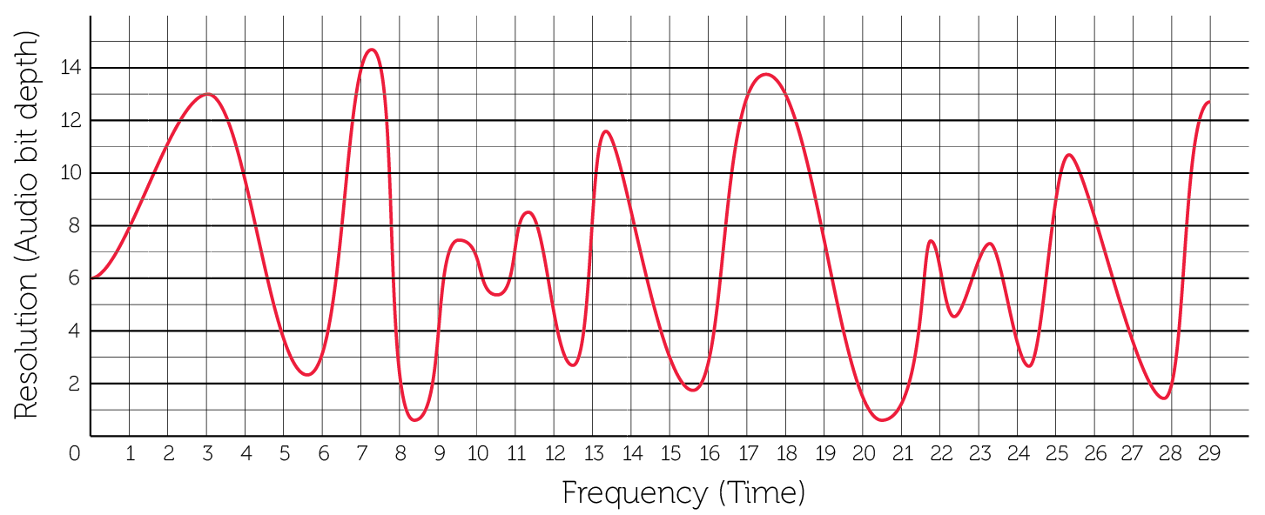
0 | 1 | 2 | 3 | 4 | 5 | 6 | 7 | 8 | 9 | 10 | 11 | 12 | 13 | 14
6 | 8
15 | 16 | 17 | 18 | 19 | 20 | 21 | 22 | 23 | 24 | 25 | 26 | 27 | 28 | 29
- Replot all of your figures on to the graph below and create a bar chart from the points. The first two points have been drawn for you.
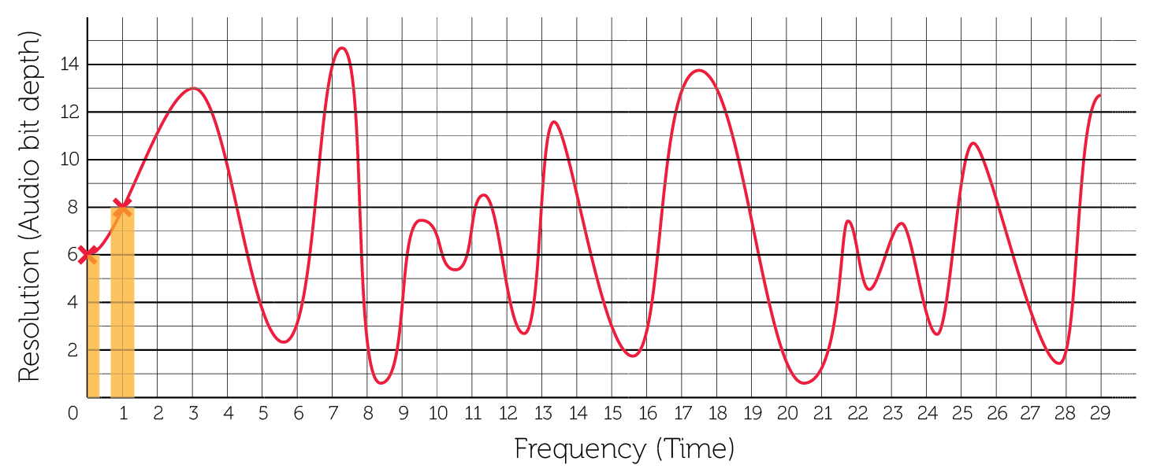
- How accurately does this represent the original sound wave? Where are there inaccuracies in the digital reproduction of the wave?

Task 2
- What would you need to do in order to improve the accuracy of the recording?

- In reality, each of the measurements on the y-axis would be given a binary value and that would be recorded in the audio data file. Using Table 1 below write out the binary values for each of the first ten samples given in Table 2. There are 16 sampling points on the y-axis so four bits must be used in order to provide enough different bit patterns for each sampling point.
Y | Bit value
1 | 0001
2 | 0010
3 | 0011
4 | 0100
5 | 0101
6 | 0110
7 | 0111
8 | 1000
9 | 1001
10 | 1010
11 | 1011
12 | 1100
13 | 1101
14 | 1110
15 | 1111
Table 1
Sample | 0 | 1 | 2 | 3 | 4 | 5 | 6 | 7 | 8 | 9
Value | 6 | 8 | 11 | 13 | 10 | 4 | 6 | 14 | 2 | 4
Binary value | 0110 | 1000
Table 2

The Binary values in the third row above represent the data that would be stored to recreate this very short sound file of 10 samples.
- What would be the file size in bytes of the 10 samples in Question 3?

The resolution is the accuracy with which the wave height is measured – the higher the resolution, the more accurate the measurement at a particular sample point.
- What would the file size of samples in question 3 become if you increased the resolution to allow for 256 different points on the y-axis?

- How would this affect the quality of the recording?

- The sampling frequency is the frequency with which the measurements are taken – a higher sampling frequency means measurements are taken more often within the same period of time. How would this affect the quality of the recording?

- Explain the relationship between the quality of playback and the file size.

- Calculate the file size in mebibytes of a music track on a CD that has the following properties:
- Resolution: 16-bits
- Sample rate: 44.1 kHz
- Length: 3 minutes 30 seconds

